Guava veda naturals
Product: Guava Chutney
Submitted to : Dr. Geeta Mehra Submitted by : Karmanveer (7361) Yashika (7338) Avni (7350) Drishti (7349) Anchal (7354)

S.No. | Topic | Page No.
1. | Product Idea | 2
2. | Area | 3
3. | Plant Layout | 4
4. | Feasibility  Raw Material Required | 5
5. | Food Safety Standards Guidelines  Licensing/Registration | 6
6. | Labelling Requirements  Machinery Required for Guava Chutney Production | 7-8
7. | Flowchart of Guava Chutney Production | 9
8. | Table of Critical Control Points  Physio chemical tests  - Microbiological Tests for Finished Product  - Chemical Tests for Finished Product  - Physical Tests for Finished Product  - Nutritional Requirements | 10-12
9. | Graph showing change in moisture content  Transportation | 13
10. | Electricity Availablity  Water Supply  Funding and Subsidies | 14
11. | Waste Product Management and By-Product Utilisation | 15
12. | Marketing Strategy | 16
13. | Piechart for Cost of Production | 17
14. | Conclusion  References | 18

PRODUCT IDEA

The idea of starting a guava chutney factory did not come to me in a classroom or a business seminar—it was born in my village, among orchards heavy with ripe guavas and the familiar aroma of homemade food.
Every winter, guava trees around our area would be full of fresh, juicy fruits. Farmers worked hard, yet many guavas were sold at very low prices or wasted due to lack of proper markets and processing facilities. I often noticed heaps of unsold guavas at local markets, slowly losing their value with each passing day. This troubled me. How could such a nutritious and delicious fruit go to waste?
At home, guava chutney had always been special. Made using fresh guavas, green chilies, spices, and love, it was more than just a side dish—it was a taste of tradition. One day, while enjoying this chutney with a simple meal, a thought struck me: Why can’t this homemade taste reach more people? Why can’t guava be preserved in a way that benefits both farmers and consumers?
I began observing market trends and realized that people today are increasingly drawn toward natural, preservative-free, and traditional foods. Chutneys, pickles, and ready-to-eat condiments were gaining popularity, especially those made from fruits. Guava, rich in vitamin C, fibre, and antioxidants, had immense potential—but it was still underutilized.
This realization inspired me to think beyond personal consumption. I saw an opportunity to create something meaningful: a guava chutney factory that could reduce fruit wastage, provide fair income to local farmers, create employment, and deliver a healthy, flavourful product to consumers.
The vision slowly became clearer. I imagined a small processing unit near guava-growing areas, using simple technology but strict quality control. Traditional recipes blended with modern food safety practices could create a product that is both authentic and market-ready.
What started as a concern for wasted guavas turned into a dream of entrepreneurship. The guava chutney factory is not just a business idea for me—it is a step toward value addition, sustainability, and preserving local flavors. This inspiration continues to motivate me to work hard, learn more, and turn this idea into reality.

Area
The area required depends on the scale of production.
1. Total Area Requirement
Minimum required area: 800–1200 sq. ft.
This area allows smooth workflow, hygiene, and future expansion.
2. Area-wise Distribution
- Section : Approx. Area (sq. ft.)
- Purpose : Raw material receiving & washing 150–200
- Washing and sorting of guava
- Preparation & cutting section 100–150
- Peeling and cutting
- Processing & cooking area 200–250
- Pulping and cooking
- Packaging & labelling section 150–200
- Filling, sealing, labeling
- Finished goods storage 100–150
- Storage of packed chutney
- Utility & office area 80–100
- Office, records, utilities
- Quality control / hygiene area 50–80
- Sampling & inspection
3. Location Considerations
- Preferably near guava-producing areas
- Availability of clean water and electricity
- Good transport connectivity
- Away from pollution and waste dumping areas
- Complies with FSSAI hygiene norms
4. Land Type
- Industrial or semi-industrial land
- Rural area is suitable for lower cost
- Can be rented or owned

Plant layout

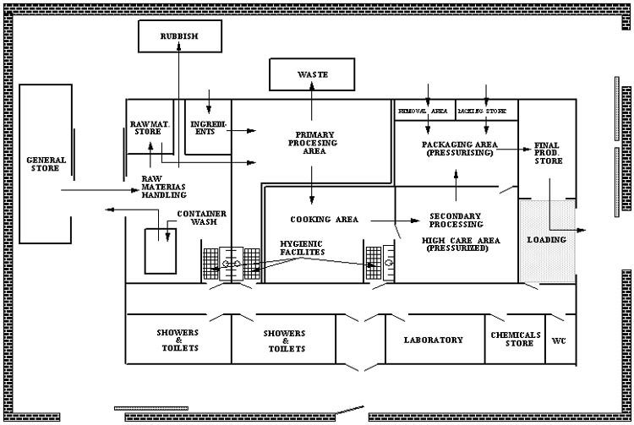

Technical Feasibility
Technical feasibility refers to the evaluation of whether a proposed project, system, or product can be successfully developed and implemented using existing or available technology. In an industrial context, it plays a crucial role in determining whether the technical resources, expertise, and infrastructure required for a project are adequate and practical.
1. Meaning and Importance
Technical feasibility focuses on assessing the technical aspects of a project before its execution. Industries must ensure that the proposed idea is not only innovative but also technically achievable. This evaluation helps reduce risks, avoid costly failures, and ensure efficient use of resources.
For example, if a manufacturing company plans to introduce automation using robotics, it must evaluate whether the current machinery, workforce skills, and infrastructure can support such integration.
2. Key Components of Technical Feasibility
a) Technology Availability
The first step is to determine whether the required technology already exists or needs to be developed. If the technology is too advanced, expensive, or unavailable, the project may not be feasible.
b) Technical Expertise
Industries need skilled personnel such as engineers, technicians, and IT professionals. A lack of expertise may require training or hiring, which increases cost and time.
c) Infrastructure Requirements
This includes physical facilities, machinery, tools, and IT systems. The industry must evaluate whether existing infrastructure can support the new project or if upgrades are necessary.
d) Compatibility and Integration
New systems must be compatible with existing processes and technologies. Poor integration can lead to inefficiencies and operational disruptions.
e) Reliability and Performance
The proposed technology should be reliable and capable of performing efficiently under industrial conditions. Frequent breakdowns or inefficiencies can lead to losses.
3. Steps in Evaluating Technical Feasibility
Define Project Requirements – Clearly outline the technical needs of the project.
Analyze Existing Systems – Study current technology and processes.
Identify Gaps – Determine what additional resources or technologies are required.
Assess Risks – Evaluate potential technical challenges and limitations.
Estimate Time and Cost – Calculate the time required for development and implementation.
Make Decision – Decide whether the project is technically viable.
4. Examples in Industry
Manufacturing Industry: Introduction of automated assembly lines requires evaluation of machine compatibility and worker training.
IT Industry: Development of new software systems requires checking hardware capacity, programming tools, and cybersecurity measures.
Pharmaceutical Industry: Production of a new drug requires advanced laboratory equipment and compliance with technical standards.
5. Advantages of Technical Feasibility Analysis
Reduces project risk
Improves planning and decision-making
Ensures efficient use of resources
Identifies technical limitations early
Enhances chances of project success
6. Limitations
May require detailed analysis and time
Predictions may not always be accurate
Rapid technological changes can affect feasibility
Conclusion
Technical feasibility is a vital part of industrial project planning. It ensures that a project is not only innovative but also practical and achievable with available resources and technology. By carefully analyzing technical requirements, industries can minimize risks, optimize performance, and achieve successful implementation of projects.

Legal Feasibility
Legal feasibility refers to the extent to which a proposed business idea, project, or operation complies with all applicable laws, regulations, and legal requirements within a specific industry. It is a critical component of overall feasibility analysis because even a profitable and technically viable project can fail if it violates legal norms. Assessing legal feasibility ensures that the business can operate smoothly without facing legal disputes, penalties, or shutdowns.
One of the primary aspects of legal feasibility is compliance with industry-specific regulations. Different industries are governed by different regulatory frameworks. For example, the pharmaceutical industry must comply with strict drug approval laws, while the food industry must follow safety and hygiene standards. A business must identify all relevant laws, including licensing requirements, permits, and certifications necessary to operate legally. Failure to obtain these can result in fines or closure of the business.
Another important factor is business structure and registration. Choosing the appropriate legal structure—such as sole proprietorship, partnership, or company—affects taxation, liability, and regulatory obligations. Proper registration with government authorities is mandatory to ensure the business is recognized as a legal entity. This also includes compliance with labor laws, which govern employee rights, wages, working conditions, and social security benefits.
Intellectual property rights (IPR) also play a significant role in legal feasibility. Businesses must ensure that their products, branding, or technology do not infringe on existing patents, trademarks, or copyrights. At the same time, they should protect their own intellectual property to maintain a competitive advantage. Ignoring IPR issues can lead to costly legal disputes and reputational damage.
Additionally, environmental laws and regulations are increasingly important across industries. Companies must adhere to environmental standards related to waste management, emissions, and resource usage. Non-compliance can result in severe penalties and can also harm the company’s public image. For industries such as manufacturing or mining, environmental clearance is often a prerequisite before starting operations.
Contractual obligations form another key element of legal feasibility. Businesses frequently enter into agreements with suppliers, customers, employees, and partners. These contracts must be legally sound and clearly define rights and responsibilities to avoid disputes. Reviewing and drafting contracts carefully helps minimize risks and ensures enforceability in case of disagreements.
Furthermore, taxation laws must be considered. A business must comply with applicable tax regulations, including income tax, GST, and other local taxes. Understanding tax liabilities and maintaining proper financial records is essential to avoid legal complications and penalties.
In conclusion, legal feasibility is essential for ensuring that a business idea can be implemented without violating laws or facing legal challenges. It involves thorough analysis of regulatory requirements, licensing, intellectual property, environmental laws, contracts, and taxation. By addressing these factors early in the planning stage, businesses can reduce risks, ensure compliance, and create a strong foundation for long-term success.

Financial Feasibility

Financial feasibility evaluates whether the proposed GuavaVeda Naturals guava chutney manufacturing unit is economically viable and capable of generating sustainable returns on investment. It involves a detailed analysis of capital requirements, production costs, revenue projections, profitability, and available funding sources.

1. Capital Investment
The estimated initial investment required to establish the guava chutney processing unit at Hajipur, Vaishali District (Bihar) is as follows:

Land & Building (Rent/Purchase): Rs. 2,00,000 - Rs. 5,00,000
Machinery & Equipment: Rs. 5,00,000 - Rs. 10,00,000
Furniture, Fixtures & Utilities: Rs. 80,000 - Rs. 1,50,000
Initial Working Capital: Rs. 1,50,000 - Rs. 3,00,000
Miscellaneous & Pre-operative Expenses: Rs. 50,000 - Rs. 1,00,000
----------------------------------------------------------
Total Estimated Investment: Rs. 9,80,000 - Rs. 20,50,000

2. Monthly Cost of Production
The estimated monthly operational costs for the unit are as follows:

Raw Materials (guava, spices, sugar, vinegar, preservatives): Rs. 60,000 - Rs. 80,000
Labour and Wages: Rs. 40,000 - Rs. 60,000
Electricity and Utilities: Rs. 18,000 - Rs. 40,000
Packaging Materials (bottles, labels, cartons): Rs. 15,000 - Rs. 25,000
Transportation and Distribution: Rs. 10,000 - Rs. 20,000
Maintenance and Miscellaneous: Rs. 10,000 - Rs. 15,000
----------------------------------------------------------
Total Monthly Cost of Production: Rs. 1,53,000 - Rs. 2,40,000

3. Revenue Projection
Based on a small-scale unit producing 500-1,000 kg of chutney per day with 25 working days per month at 60% capacity utilisation:

Monthly Production: 12,500 - 15,000 kg
Average Selling Price (MRP): Rs. 120 - Rs. 200 per kg
Estimated Monthly Revenue: Rs. 3,60,000 - Rs. 6,00,000
Estimated Annual Revenue: Rs. 43,20,000 - Rs. 72,00,000

4. Profitability Analysis
The projected profitability of the unit is as follows:

Gross Profit Margin: 30% - 45%
Estimated Monthly Net Profit: Rs. 80,000 - Rs. 2,00,000
Estimated Annual Net Profit: Rs. 9,60,000 - Rs. 24,00,000
Return on Investment (ROI): 48% - 117% (approximate)
Break-even Period: 18 - 24 months from commencement of operations

5. Funding Sources
The following government schemes and financial instruments are available for funding the project:

a) PMEGP (Prime Minister's Employment Generation Programme): Provides margin money subsidy of 15-35% on project cost for first-generation entrepreneurs in agro-processing.
b) MUDRA Loan (Pradhan Mantri Mudra Yojana - Kishore/Tarun): Collateral-free loans up to Rs. 10 lakh to Rs. 50 lakh for small manufacturing units.
c) Bihar Industrial Investment Promotion Policy: Capital subsidy on plant, machinery, and land development for units established in Bihar.
d) NABARD / SBI MSME Loans: Low-interest loans for agro-processing units under priority sector lending norms.
e) NHB (National Horticulture Board): Financial assistance for horticulture-based processing and value-addition units.

6. Financial Risk Factors
Seasonal variation in guava availability (October to February) may affect raw material costs and production continuity during off-season months.
Fluctuations in electricity tariffs and packaging material prices may impact profit margins.
Initial marketing and distribution expenses may affect early-stage profitability before the brand establishes recognition in target markets.

Conclusion (Financial Feasibility)
The guava chutney processing unit of GuavaVeda Naturals presents a financially viable and attractive investment opportunity. With a moderate capital requirement, competitive production costs, and strong revenue potential, the project is expected to achieve break-even within 18-24 months and generate a healthy return on investment. Government subsidies and MSME funding schemes further reduce the financial burden, making this project highly feasible from a financial perspective.

Market Feasibility

Market feasibility assesses the potential demand for GuavaVeda Naturals guava chutney in the existing and emerging market landscape. It examines market size, consumer trends, competition, distribution strategies, and growth opportunities to determine whether there is a sufficient and sustainable market for the proposed product.

1. Market Size and Growth Potential
The Indian condiments and sauces market is one of the fastest-growing segments in the food and beverage sector:

Indian Condiments & Sauces Market Size (2024): Approximately Rs. 22,000 crore
Projected CAGR (2024-2030): 8% - 10%
Chutney and Pickle Segment Annual Growth: 9% - 12%
Bihar & Eastern India Regional Market: Significant untapped potential with growing urban consumer base

2. Consumer Trends Driving Demand
Several key consumer trends support the viability of the guava chutney product:

a) Natural and Preservative-Free Products: Increasing consumer preference for food products free from artificial additives and chemical preservatives.
b) Regional and Ethnic Flavours: Rising popularity of authentic, region-specific food products among urban consumers across India.
c) Health-Conscious Eating: Guava is rich in Vitamin C, dietary fibre, and antioxidants, attracting health-conscious and wellness-oriented buyers.
d) Premiumization of Condiments: Consumers are willing to pay a premium for quality, hygienically processed, well-packaged condiments.
e) Vocal for Local Movement: The Vocal for Local initiative encourages support for local food businesses and indigenous products, boosting demand for regional brands like GuavaVeda Naturals.

3. Target Market Segments
GuavaVeda Naturals guava chutney targets the following consumer segments:

a) Urban Households: Health-conscious families in Patna, Delhi, Lucknow, and Kolkata seeking natural condiments with authentic regional taste.
b) Local Households (Bihar): Daily consumers familiar with guava chutney as a traditional accompaniment with meals and snacks.
c) Food Service Industry: Hotels, restaurants, dhabas, cafes, and catering services requiring quality chutney consistently in bulk quantities.
d) Retail Chains & Supermarkets: Modern trade channels including Big Bazaar, More, Reliance Fresh, and regional grocery chains in Bihar and neighbouring states.
e) Online E-commerce Consumers: Tech-savvy buyers purchasing specialty and regional food products on Amazon, Flipkart, and Meesho.
f) Gift and Specialty Market: Regional specialty food gifting, tourism-related products, and food exhibitions targeting local and national audiences.

4. Competitive Landscape
An analysis of the competitive environment reveals the following:

Organised Sector Competitors: Brands such as Maggi, Tops, Kissan, and MTR offer sauces and chutneys but have limited guava-specific product variants, creating a market gap.
Unorganised / Local Competitors: Local homemade and small-scale chutney producers dominate rural and semi-urban markets but lack standardised quality, branding, and adequate shelf life.
Competitive Advantage of GuavaVeda Naturals: Locally sourced Hajipur guava, traditional recipe, FSSAI-certified hygienic processing, attractive packaging, and competitive pricing create strong differentiation in the market.

5. Distribution and Sales Channels
GuavaVeda Naturals will adopt a multi-channel distribution strategy to maximise market reach:

Direct Distribution: Local kirana stores, weekly haats (markets), and targeted sales in Hajipur and surrounding villages and towns in Vaishali district.
Retail Distribution: Partnership with district-level distributors to supply supermarkets and grocery stores in Patna, Muzaffarpur, and other major Bihar cities.
Institutional Sales (B2B): Direct supply agreements with hotels, restaurants, catering companies, and educational institution canteens.
Online Marketplace: Listing on Amazon, Flipkart, Meesho, and JioMart for pan-India geographic reach at low distribution cost.
Exhibitions and Trade Fairs: Participation in food expos and agricultural trade fairs to build brand visibility and attract wholesale buyers.

6. Market SWOT Analysis

Strengths:
- Unique regional product with authentic taste and compelling brand story
- Fresh, locally sourced Hajipur guava ensuring superior quality and freshness
- Natural, preservative-free formulation aligned with modern health trends
- Low raw material cost due to proximity to guava-growing farms in Vaishali district

Weaknesses:
- Initial limited brand recognition in urban and out-of-state markets
- Seasonal dependency on guava availability (October to February crop season)
- Smaller production scale compared to established national competitors

Opportunities:
- Growing national demand for natural, regional, and specialty condiments
- E-commerce platforms offering pan-India market access at low entry cost
- Government support for agro-processing, MSME, and food businesses in Bihar
- Export potential to Indian diaspora in USA, UK, Canada, and the Middle East

Threats:
- Competition from larger food processing companies entering the regional chutney space
- Fluctuating raw material prices during off-season and adverse weather years
- Evolving FSSAI food safety regulations requiring continuous compliance investment

7. Pricing Strategy
The pricing of GuavaVeda Naturals guava chutney is designed to be competitive, accessible, and profitable across all consumer segments:

200 g Pack: Rs. 60 - Rs. 80 (mass market and impulse purchase appeal)
500 g Pack: Rs. 130 - Rs. 180 (household and regular consumer segment)
1 kg Pack: Rs. 220 - Rs. 300 (bulk buyers and institutional / B2B customers)

Conclusion (Market Feasibility)
The market feasibility analysis confirms that there is a strong and growing demand for quality guava chutney in India, particularly in Bihar and Eastern India. GuavaVeda Naturals is well-positioned to capitalise on this opportunity by leveraging its natural ingredients, authentic regional recipe, competitive pricing, and multi-channel distribution approach. With increasing consumer preference for natural condiments and supportive government schemes for agro-processing, the product has significant market potential both locally and nationally. The market feasibility of this project is highly positive and strongly supports the establishment of the GuavaVeda Naturals guava chutney processing unit.

Raw Material Required
Raw Material | Quantity Required | Purpose
Fresh Guava | 55–65 kg | Main raw material; provides pulp, flavour, and nutrients
Sugar | 15–20 kg | Sweetening agent and preservation
Salt | 1.5–2.0 kg | Taste enhancement and preservation
Green Chilies | 1.0–1.5 kg | Spice and flavour
Ginger | 0.8–1.2 kg | Flavour and aroma
Spices (cumin, pepper, etc.) | 0.5–1.0 kg | Taste and seasoning
Vinegar / Citric Acid | 0.3–0.5 kg | Acidity regulator and preservation
Permitted Preservative (e.g., Sodium Benzoate) | As per FSSAI limits | Shelf-life extension
Water | Balance quantity | Processing and consistency adjustment

Food Safety Standards Guidelines

1. Hygiene and Sanitation Standards
The food processing unit must maintain high standards of cleanliness and sanitation. Processing areas should be regularly cleaned, pest-free, and well-ventilated. Only potable water should be used for washing and processing.
2. Good Manufacturing Practices (GMP)
All equipment and machinery must be food-grade, non-toxic, and corrosion-resistant. Proper cleaning and maintenance schedules should be followed to avoid contamination.
3. Good Hygiene Practices (GHP)
Workers must follow strict personal hygiene practices, including use of gloves, caps, and masks. Ill or injured workers should not be allowed to handle food products.
4. Control of Raw Materials and Ingredients
Only fresh and good-quality raw materials should be used. Use of food additives and preservatives must be within the limits prescribed by FSSAI.
5. Quality Control and Testing
Regular quality checks and microbiological testing should be carried out. Records of testing and corrective actions must be maintained.

Licensing / registration

- Apply on *Foscos* for *Registration / State Licence / Central Licence* depending on your business size (turnover/capacity).
- While applying, choose the product category for chutney under *Food Product Categories (FPC): “Fruit-based spreads (e.g., chutney)
- Keep a *documented FSMS plan* and meet the GMP requirements.

Labelling requirements

As per Food Safety and Standards: -
- Name of food (e.g., “Guava Chutney”)
- List of ingredients (descending order by weight/volume)
  - Veg / non-veg symbol (chutney is usually veg)
  - Net quantity (g / kg)
  - Batch/Lot/Code number
  - Date of manufacturing/packing + Best Before/Use By
  - Nutritional information (as required format)
  - Allergen declaration (if any allergen ingredient is used)
  - Name & full address of manufacturer (and marketer/importer if applicable)
  - Customer care details (phone/email for complaints)
  - FSSAI logo + Licence/Registration number

Machinery Required for Guava Chutney Production
a) Raw Material Reception & Sorting Table
- Used for manual sorting and grading of fresh guava fruits.
b) Washing Machine (Bubble / Spray Washer)
- Removes dirt, pesticides, and surface contaminants.
c) Peeling & Cutting Machine
- Peels and slices guava into uniform pieces.
d) Pulping / Crusher Machine
- Converts guava pieces into pulp for further processing.
e) Steam Jacketed Kettle (with Agitator)
- Used for cooking pulp with spices, sugar, salt, and preservatives.
f) Spice Mixing & Grinding Unit
- Prepares fine spice blends required for chutney formulation.
g) Homogenizer
- Ensures uniform texture and consistency of chutney.
h) Filling & Sealing Machine
- Fills chutney into jars/pouches and seals them hygienically.
i) Pasteurization Unit
- Extends shelf life by destroying spoilage microorganisms.
j) Labeling & Packaging Machine
- Final packaging and branding of product.

Efficiency of Machinery:-
Modern food processing machinery offers 85–95% operational efficiency. Automation reduces material loss, ensures uniform quality, and improves hygiene standards.

Yield and Output:-
Average yield: 55–65% chutney from fresh guava (depending on variety and maturity).
Typical small-scale unit output: 500–1000 kg chutney/day.
Medium-scale unit output: 2–5 tons/day.

Energy Requirement:-
Power requirement ranges from 15–30 kW for small to medium units.
Major energy-consuming equipment includes pulper, kettle agitator, homogenizer, and packaging machine.
Steam or electric heating can be used depending on scale.

Manpower Requirement / Labour required:-
Category of Labour | Number Required | Nature of Work | Skill Level
Production Supervisor | 1 | Overall supervision of processing and quality control | Skilled
Machine Operator | 2 | Operation of pulper, cooker, and packaging machines | Semi-skilled
Quality Control Assistant | 1 | Monitoring hygiene, sampling, and basic testing | Skilled
Helpers / Workers | 4–5 | Washing, cutting, loading, cleaning operations | Unskilled
Packaging Workers | 2 | Filling, sealing, labeling, and packing | Semi-skilled
Store / Inventory Assistant | 1 | Raw material and finished goods handling | Semi-skilled
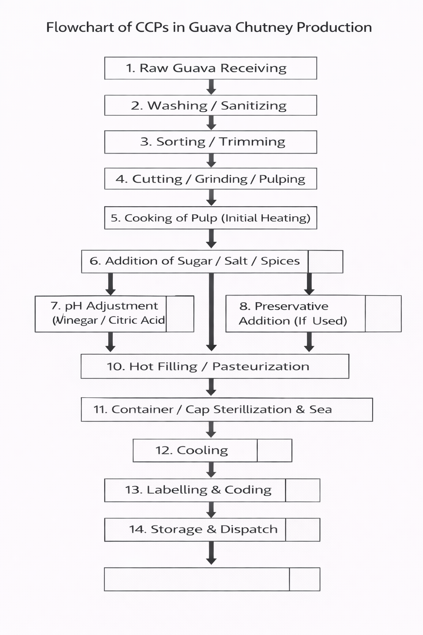
Table of Critical Control Points :-
Process Step | Potential Hazards (B/C/P) | Control Measures | CP / CCP | Critical Limits (if CCP) | Monitoring | Corrective Action | Records
Raw material receiving | B: microbial load; C: pesticide residues; P: stones/dirt | Approved suppliers, visual inspection | CP | - | Visual check per lot | Reject contaminated lot | Raw material receipt log
Washing & sanitization | B: contaminated water; C: excess sanitizer | Potable water, controlled sanitizer | CP | - | Water quality & sanitizer conc. | Rewash / adjust sanitizer | Washing & sanitizer log
Sorting & cutting | P: foreign matter; B: spoiled fruit | Manual sorting and trimming | CP | - | Continuous visual inspection | Remove defective fruits | Sorting record
Pulping / grinding | P: metal fragments; B: contamination | Sieves, magnets, sanitation | CP | - | Equipment check per shift | Stop line, replace sieve | Maintenance & sanitation log
Cooking of pulp | B: survival of pathogens | Controlled heating | CCP | ≥85–90°C for required time | Temperature-time monitoring | Continue heating / hold batch | Cooking temperature log
Ingredient addition | B: contamination; C: adulterants | Approved ingredients, weighing | CP | - | Weighing per batch | Reject/replace ingredient | Ingredient weighing log
pH adjustment | B: pathogen survival | Addition of vinegar/citric acid | CCP | Final pH ≤ 4.6 | pH meter check per batch | Adjust pH and recheck | pH monitoring log
Preservative addition | C: overdose/underdose | Accurate weighing | CCP | Within FSSAI limits | Batch-wise verification | Hold batch, correct dose | Preservative record
Final cooking / concentration | B: under-processing | Time–temperature control | CP | - | Temp/Brix check | Continue cooking | Cooking/Brix log
Hot filling & pasteurization | B: post-process contamination | Hot filling | CCP | 80–90°C for 10–15 min | Fill temp monitoring | Reheat / stop filling | Pasteurization log
Sealing & packaging | B/P: contamination, leakage | Seal integrity checks | CP | - | Visual & torque check | Repack / reseal | Packaging inspection log
Storage & dispatch | B: spoilage | Clean dry storage, FIFO | CP | - | Daily inspection | Isolate affected stock | Storage & dispatch log

Physiochemical tests:-
Table 1: Microbiological Tests for Finished Product
Test Name | Microorganism Detected | Purpose | Acceptable Limit
Total Plate Count (TPC) | Total viable bacteria | Overall microbial load | ≤ 10⁴ CFU/g
Yeast & Mold Count | Yeasts and molds | Spoilage detection | ≤ 10² CFU/g
Coliform Test | Coliform bacteria | Hygiene indicator | Absent / ≤ 10 CFU/g
Escherichia coli | Fecal contamination | Safety assessment | Absent
Salmonella spp. | Pathogenic bacteria | Food safety | Absent in 25 g
Staphylococcus aureus | Toxin-producing bacteria | Product safety | ≤ 10² CFU/g

Table 2: Chemical Tests for Finished Product
Test Name | Parameter Tested | Purpose | Acceptable Range / Limit
pH Test | Acidity / Alkalinity | Product stability and safety | 3.0 – 4.5
Total Soluble Solids (TSS) | Sugar concentration (°Brix) | Sweetness and consistency | 35 – 45 °Brix
Moisture Content | Percentage moisture | Shelf-life determination | 40 – 45 %
Total Acidity | Organic acid content | Taste and preservation | 0.8 – 1.2 %
Reducing Sugars | Glucose and fructose | Sugar quality analysis | As per formulation
Total Sugars | Overall sugar content | Taste and energy value | 22 – 28 %

Table 3: Physical Tests for Finished Product
Test Name | Physical Parameter | Purpose of Test | Acceptable Range / Observation
Colour Test | Appearance / colour | Consumer acceptability | Uniform light pink to reddish
Texture / Consistency Test | Thickness, spreadability | Product quality and mouthfeel | Smooth, semi-thick consistency
Taste Test | Sweetness, sourness, spiciness | Sensory quality evaluation | Balanced sweet–sour–spicy taste
Aroma / Flavour Test | Characteristic guava aroma | Freshness and acceptability | Pleasant aroma, no off-odour
Viscosity Test | Flow property | Uniform filling and stability | Consistent flow, no separation
Foreign Matter Test | Presence of impurities | Product cleanliness | Free from foreign matter

Table 4: Nutritional Requirements
Nutrient | Nutritional Composition (per 100 g)
Energy | 130–160 kcal
Carbohydrates | 30–38 g
Sugars | 22–28 g
Dietary Fibre | 3.5–5.0 g
Protein | 0.9–1.3 g
Fat | 0.2–0.6 g
Sodium | 350–550 mg
Moisture Content | 40–45 %

Graph shows change in moisture content:-
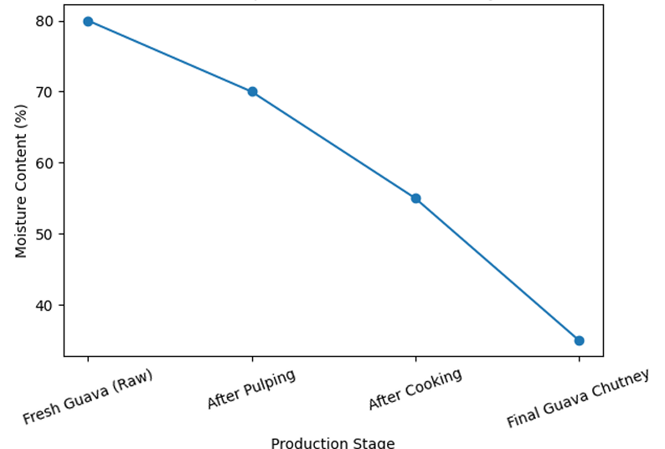

Transportation

Road Transportation
  - Hajipur has a well-developed road network which supports industrial transportation.
  - The area is connected by National Highways NH-19 and NH-122B.
  - Close proximity to NH-28 provides inter-state connectivity with Uttar Pradesh and other states.
  - State highways and local roads connect nearby villages and towns.
  - Road transport is cost-effective, flexible, and time-saving for industries.
  - Trucks, mini-trucks, and tempos are easily available for daily transportation.

Rail Transportation
  - Hajipur Junction is a major railway station under East Central Railway.
  - It provides direct rail connectivity to Patna, Muzaffarpur, Kolkata, Delhi, and Lucknow.
  - Railways are suitable for bulk transportation of raw materials and finished goods.
  - Rail transport helps reduce long-distance transportation costs.
  - It supports inter-state trade and large-scale distribution.

Electricity Availability

Power Supply Source
- Electricity supplied by North Bihar Power Distribution Company Ltd. (NBPDCL).
- Standard industrial power supply: 3-phase, 415 V.
- Average sanctioned load for small food processing unit: 20–50 kW.

Power Requirement for Guava Chutney Unit
- Washing & cutting machines: 3–5 kW
- Pulping/grinding unit: 5–7 kW
- Cooking & mixing equipment: 4–6 kW
- Packaging & sealing machines: 3–5 kW
- Refrigeration/cold storage: 5–8 kW
- Total connected load required: 20–30 kW

. Cost of Electricity
- Industrial electricity tariff: ₹6–8 per unit (kWh).
- Monthly electricity consumption: 3,000–5,000 units.
- Estimated monthly electricity cost: ₹18,000–₹40,000
Water Supply
- Adequate water supply is available in Hajipur, Vaishali district, for industrial use.
- Water is supplied through municipal sources and local groundwater facilities.
- Groundwater is available through borewells and hand pumps.
- Water is used for processing, cleaning, washing, and sanitation purposes.
- Regular water availability supports continuous industrial operations.
- Industries can install overhead tanks for water storage.
- Basic water treatment and filtration systems can be used for quality control.

Funding and Subsidies

Government Funding Support
  - Industrial units in Hajipur, Vaishali district are eligible for government financial support.
  - Funding support is available under central and state government industrial development schemes.
  - Special focus is given to MSMEs and agro-based industries.

Subsidies from State Government
  - The Bihar Government provides subsidies under its Industrial Investment Promotion Policy.
  - Subsidies are available on land, electricity, and capital investment.
  - Incentives are provided to encourage industries in developing districts.

Waste Product Management and By‑Product Utilization

Types of Waste Generated
- Solid waste: Guava peels, seeds, spoiled fruits.
- Liquid waste: Wash water from cleaning and processing.
- Packaging waste: Plastic wrappers, cartons, labels.

Solid Waste Management
- Guava peels and seeds collected separately in covered bins.
- Daily removal of organic waste from processing area.
- Organic waste generation: approx. 20–30% of raw guava weight.

By‑Product Utilization
- Guava peels and pulp residues used for compost preparation.
- Potential use in cattle feed after proper treatment.
- Scope for extraction of pectin from guava waste (future).

Liquid Waste Management
- Wastewater generated: 1,500–2,000 litres/day.
- Water reused for floor cleaning and gardening after filtration.
- No direct discharge of untreated wastewater.

Packaging Waste Management
- Segregation of plastic, paper, and cardboard waste.
- Sale of recyclable materials to authorized recyclers.
- Reduction in packaging waste through bulk procurement.

Marketing Strategy

Brand Name and Product Identity
- Proposed brand name: GuavaVeda Naturals
- Product name: Amrit Guava Chutney
- Brand concept: Fusion of traditional Indian taste with natural, hygienic processing.
- Brand tagline: 'Pure Fruit. Pure Taste.'

Product Concept and Uniqueness
- Prepared from fresh, locally sourced Hajipur guava.
- Traditional recipe with modern hygienic processing.
- No artificial colours; only permitted natural preservatives.
- Authentic taste highlighting Bihar’s fruit richness.

Target Market
- Health-conscious urban consumers.
- Local households in Bihar.
- Restaurants, cafés, and street food vendors.
- Tourists seeking regional specialty products.

Packaging and Presentation
- Available pack sizes: 200 g, 500 g, and 1 kg.
- Food-grade glass bottles and premium PET jars.
- Attractive earthy label design reflecting natural theme.
- Tamper-proof and leak-proof packaging.

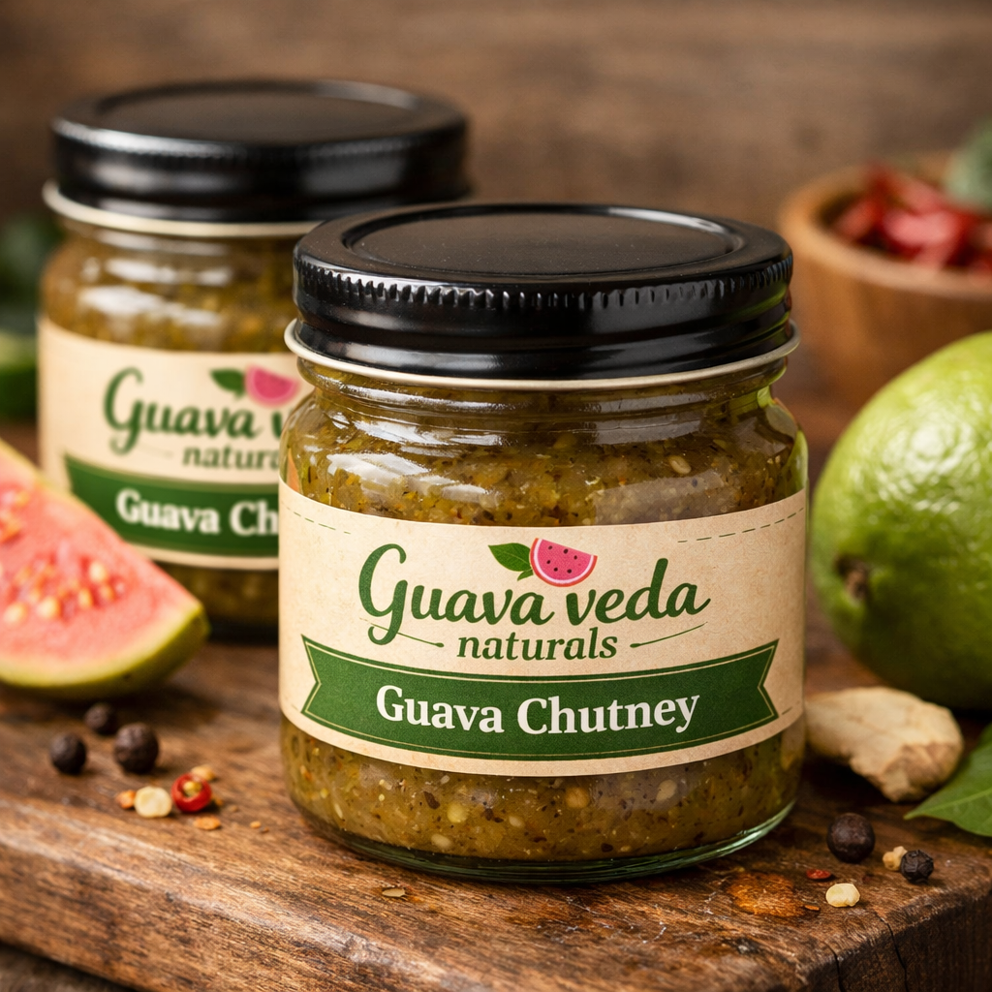
Figure:- Finished product

Pie chart for Cost of Production:-
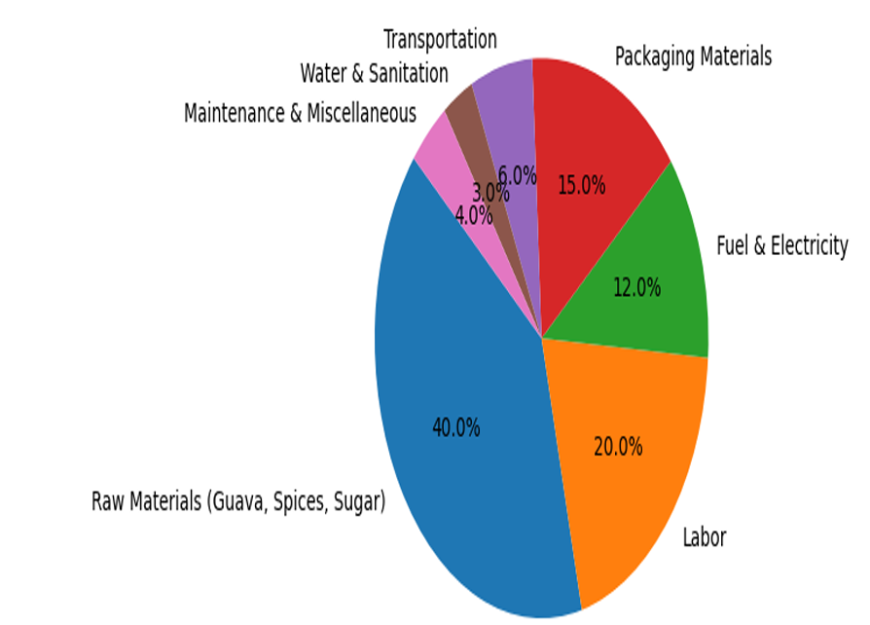
Conclusion
The establishment of a guava chutney processing industry is a technically feasible, economically viable, and sustainable venture within the food processing sector. By converting perishable, nutrient-rich guava into a shelf-stable, value-added product, the industry helps reduce post-harvest losses while retaining nutritional and sensory quality. The production process is simple, cost-effective, and suitable for small- to medium-scale units, requiring basic equipment and standard food safety practices. With proper quality control, regulatory compliance, and effective marketing, the guava chutney industry can enhance farmer income, meet consumer demand for traditional nutritious foods, and support sustainable agricultural development.
Refernces
1. Ranganna, S. (2014). Handbook of Analysis and Quality Control for Fruit and Vegetable Products. 2nd Edition, McGraw Hill Publishing Co. Ltd., New Delhi.
2. Gopalan, C., Ramasastri, B. V., & Balasubramanian, S. C. (2004). Nutritive Value of Indian Foods. National Institute of Nutrition (NIN), ICMR, Hyderabad.
3. Fellows, P. J. (2000). Food Processing Technology: Principles and Practice. Woodhead Publishing Limited, CRC Press, Cambridge.
4. FAO. (2011). Guide to Good Hygiene Practices for Beverage and Fruit Processing Industries. Food and Agriculture Organization of the United Nations, Rome.
5. Thakur, N. S. (2018). Preparation and storage potential of chutney from wild pomegranate (Punica granatum L.). Journal of Pharmacognosy and Phytochemistry, 7(1), 2749–2753.

